

Practical No. : 3
Aim - Implement Control Structures and Form Validation; Create a Grading System Based on User-Entered Marks
Software/Tools Required –
VSCode, Chrome, HTML%, CSS3, Javascript (ES6)
Experiment Program Code –
index.html
<!DOCTYPE html>
<html lang="en">
<head>
<meta charset="UTF-8">
<meta name="viewport" content="width=device-width, initial-scale=1.0">
<title>Student Grade Calculator</title>
<link rel="stylesheet" href="style.css">
</head>
<body>
<div class="card">
<h2>Student Grading System</h2>

<div class="form-group">
<label for="name">Student Name</label>
<input type="text" id="name" placeholder="Enter student name">
</div>

<div class="form-group">
<label for="marks">Overall Marks (0 – 100)</label>
<input type="number" id="marks" min="0" max="100" placeholder="e.g. 85">
</div>

<button onclick="calculateGrade()">Calculate Grade</button>

<div id="output"></div>
</div>
<script src="script.js"></script>
</body>
</html>
script.js
function calculateGrade() {
var name = document.getElementById("name").value;
var marks = Number(document.getElementById("marks").value);

if (name === "") { alert("Please enter student name."); return; }
if (document.getElementById("marks").value === "") {
alert("Please enter overall marks."); return;
}
if (marks < 0 || marks > 100) { alert("Marks must be between 0 and 100."); return; }

var grade;
if (marks >= 90) { grade = "A+"; }
else if (marks >= 80) { grade = "A"; }
else if (marks >= 70) { grade = "B"; }
else if (marks >= 60) { grade = "C"; }
else if (marks >= 50) { grade = "D"; }
else { grade = "F"; }

var result = (marks >= 50) ? "Pass" : "Fail";

var out = document.getElementById("output");
out.innerHTML =
"<strong>Student Name :</strong> " + name + "<br>" +
"<strong>Overall Marks :</strong> " + marks + " / 100<br>" +
"<strong>Grade :</strong> " + grade + "<br>" +
"<strong>Result :</strong> " + result;
out.style.display = "block";
}
Output –
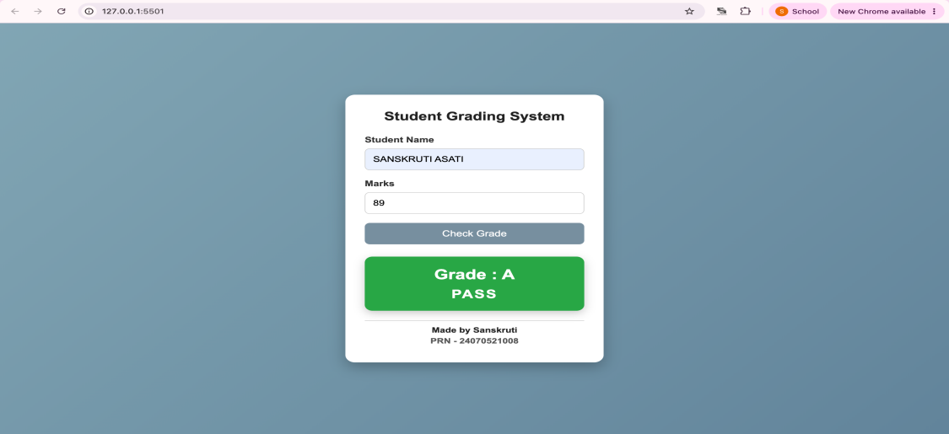
Case Study Title –
Password Validation Webpage using Form Validation and Control Structures

Case Study Program Code –

index.html
<!DOCTYPE html>
<html lang="en">
<head>
<meta charset="UTF-8">
<meta name="viewport" content="width=device-width, initial-scale=1.0">
<title>Student Grading System</title>
<link rel="stylesheet" href="style.css">
</head>
<body>

<header>
<h2>SYMBIOSIS INSTITUTE OF TECHNOLOGY, NAGPUR</h2>
<p>Department of Computer Science & Engineering</p>
</header>

<div class="container">

<h1>Student Grading System</h1>

<div class="student-details">

<div class="input-box">
<label>Student Name</label>
<input type="text" id="name" placeholder="Enter Name">
</div>

<div class="input-box">
<label>PRN Number</label>
<input type="text" id="prn" placeholder="Enter PRN">
</div>

<div class="input-box">
<label>Password</label>
<input type="password" id="password" placeholder="Create Password">
</div>

</div>

<div class="rules">
<h3>Password Requirements</h3>
<ul>
<li>Minimum 8 characters</li>
<li>At least one Uppercase letter</li>
<li>At least one Lowercase letter</li>
<li>At least one Number</li>
<li>At least one Special Symbol (@$!%*?&)</li>
</ul>
</div>

<button onclick="validatePassword()">Verify & Continue</button>

<div id="marksSection">

<h2>Enter Subject Marks</h2>

<div class="subjects">

<div class="subject">
<label>DBMS</label>
<input type="number" id="dbms" min="0" max="100">
</div>

<div class="subject">
<label>JavaScript</label>
<input type="number" id="js" min="0" max="100">
</div>

<div class="subject">
<label>CN</label>
<input type="number" id="cn" min="0" max="100">
</div>

<div class="subject">
<label>CC</label>
<input type="number" id="cc" min="0" max="100">
</div>

<div class="subject">
<label>MES</label>
<input type="number" id="mes" min="0" max="100">
</div>

</div>

<button onclick="calculateResult()">Calculate Result</button>

</div>

<div id="resultSection">

<h2>Result Card</h2>

<table>

<tr>
<th>Subject</th>
<th>Marks</th>
<th>Grade</th>
</tr>

<tr>
<td>DBMS</td>
<td id="m1"></td>
<td id="g1"></td>
</tr>

<tr>
<td>JavaScript</td>
<td id="m2"></td>
<td id="g2"></td>
</tr>

<tr>
<td>CN</td>
<td id="m3"></td>
<td id="g3"></td>
</tr>

<tr>
<td>CC</td>
<td id="m4"></td>
<td id="g4"></td>
</tr>

<tr>
<td>MES</td>
<td id="m5"></td>
<td id="g5"></td>
</tr>

</table>

<h3 id="total"></h3>
<h3 id="percentage"></h3>
<h3 id="result"></h3>

</div>

</div>

<footer>
Designed by <strong>Rudrakshi Bhandekar | PRN: 24070521012</strong>
</footer>

<script src="script.js"></script>

</body>
</html>

Style.css

*{
margin:0;
padding:0;
box-sizing:border-box;
font-family:'Segoe UI',sans-serif;
}

body{
background:url("bg.jpg") no-repeat center center fixed;
background-size:cover;
}

body::before{
content:"";
position:fixed;
top:0;
left:0;
width:100%;
height:100%;
background:rgba(8,25,52,0.55);
z-index:-1;
}

header{
width:100%;
background:linear-gradient(to right,#cf1910,#f75757);
color:white;
text-align:center;
padding:11px;
box-shadow:0 4px 10px rgba(0,0,0,.3);
}

header h2{
font-size:25px;
letter-spacing:1px;
}

header p{
font-size:13px;
margin-top:5px;
}

.container{
width:75%;
max-width:850px;
margin:35px auto;
background:rgba(255,255,255,.95);
border-radius:18px;
padding:35px;
box-shadow:0 10px 30px rgba(0,0,0,.35);
}

.container h1{
text-align:center;
color:#0f4c81;
margin-bottom:15px;
}

.student-details{
display:grid;
grid-template-columns:repeat(3,1fr);
gap:20px;
}

.input-box{
display:flex;
flex-direction:column;
}

.input-box label{
font-weight:bold;
color:#0f4c81;
margin-bottom:8px;
}

.input-box input{
padding:12px;
border:2px solid #b0c4de;
border-radius:8px;
font-size:15px;
}

.input-box input:focus{
outline:none;
border-color:#1e88e5;
}

.rules{
margin-top:25px;
background:#eef6ff;
border-left:6px solid #1e88e5;
padding:18px;
border-radius:8px;
}

.rules h3{
color:#0f4c81;
margin-bottom:10px;
}

.rules ul{
margin-left:20px;
line-height:30px;
}

button{
display:block;
margin:25px auto;
background:#ff9800;
color:white;
border:none;
padding:10px 25px;
font-size:17px;
border-radius:30px;
cursor:pointer;
transition:.3s;
}

button:hover{
background:#e65100;
transform:scale(1.05);
}

#marksSection{
display:none;
margin-top:35px;
}

#marksSection h2{
text-align:center;
color:#0f4c81;
margin-bottom:25px;
}

.subjects{
display:grid;
grid-template-columns:repeat(2,1fr);
gap:12px;
}

.subject{
background:#f7fbff;
border:2px solid #d9e8ff;
border-radius:12px;
padding:8px;
}

.subject label{
display:block;
font-weight:bold;
color:#0f4c81;
margin-bottom:10px;
}

.subject input{
width:100%;
padding:8px;
border:1px solid #ccc;
border-radius:8px;
font-size:15px;
}

.subject input:focus{
outline:none;
border-color:#1e88e5;
}

#resultSection{
margin-top:40px;
}

#resultSection h2{
text-align:center;
color:#0f4c81;
margin-bottom:20px;
}

table{
width:100%;
border-collapse:collapse;
margin-top:15px;
}

th{
background:#0f4c81;
color:white;
}

th,td{
border:1px solid #ccc;
padding:8px;
text-align:center;
}

tr:nth-child(even){
background:#f4f8ff;
}

#total,#percentage,#result{
margin-top:18px;
font-size:20px;
font-weight:bold;
text-align:center;
}

footer{
background:#0f4c81;
color:white;
text-align:center;
padding:15px;
margin-top:30px;
font-size:16px;
}

@media(max-width:768px){

.student-details{
grid-template-columns:1fr;
}

.subjects{
grid-template-columns:1fr;
}

.container{
width:65%;
padding:20px;
}

}

script.js

function validatePassword() {

let password = document.getElementById("password").value;

let pattern = /^(?=.*[a-z])(?=.*[A-Z])(?=.*\d)(?=.*[@$!%*?&^#])[A-Za-z\d@$!%*?&^#]{8,}$/;

if (pattern.test(password)) {
alert("Password Verified Successfully!");
document.getElementById("marksSection").style.display = "block";
}
else {
alert("Invalid Password!\n\nPassword should contain:\n\n• Minimum 8 characters\n• One Uppercase Letter\n• One Lowercase Letter\n• One Number\n• One Special Symbol");
document.getElementById("marksSection").style.display = "none";
}

}

function getGrade(mark) {

if (mark < 50)
return "F";
else if (mark <= 65)
return "C";
else if (mark <= 80)
return "B";
else if (mark <= 90)
return "A";
else
return "A+";

}

function calculateResult() {

let name = document.getElementById("name").value;
let prn = document.getElementById("prn").value;

let dbms = Number(document.getElementById("dbms").value);
let js = Number(document.getElementById("js").value);
let cn = Number(document.getElementById("cn").value);
let cc = Number(document.getElementById("cc").value);
let mes = Number(document.getElementById("mes").value);

if (dbms > 100 || js > 100 || cn > 100 || cc > 100 || mes > 100 ||
dbms < 0 || js < 0 || cn < 0 || cc < 0 || mes < 0) {

alert("Please enter marks between 0 and 100.");
return;

}

document.getElementById("m1").innerHTML = dbms;
document.getElementById("m2").innerHTML = js;
document.getElementById("m3").innerHTML = cn;
document.getElementById("m4").innerHTML = cc;
document.getElementById("m5").innerHTML = mes;

document.getElementById("g1").innerHTML = getGrade(dbms);
document.getElementById("g2").innerHTML = getGrade(js);
document.getElementById("g3").innerHTML = getGrade(cn);
document.getElementById("g4").innerHTML = getGrade(cc);
document.getElementById("g5").innerHTML = getGrade(mes);

let total = dbms + js + cn + cc + mes;

let percentage = (total / 500) * 100;

document.getElementById("total").innerHTML =
"Student Name : " + name +
"<br>PRN Number : " + prn +
"<br><br>Total Marks : " + total + " / 500";

document.getElementById("percentage").innerHTML =
"Percentage : " + percentage.toFixed(2) + "%";

if (dbms < 35 || js < 35 || cn < 35 || cc < 35 || mes < 35) {

document.getElementById("result").innerHTML = "❌ RESULT : FAIL";
document.getElementById("result").style.color = "red";

alert("Sorry! You have Failed.");

}
else {

document.getElementById("result").innerHTML = "✅ RESULT : PASS";
document.getElementById("result").style.color = "green";

alert("🎉 Congratulations! You Passed.");

}

}

Output –
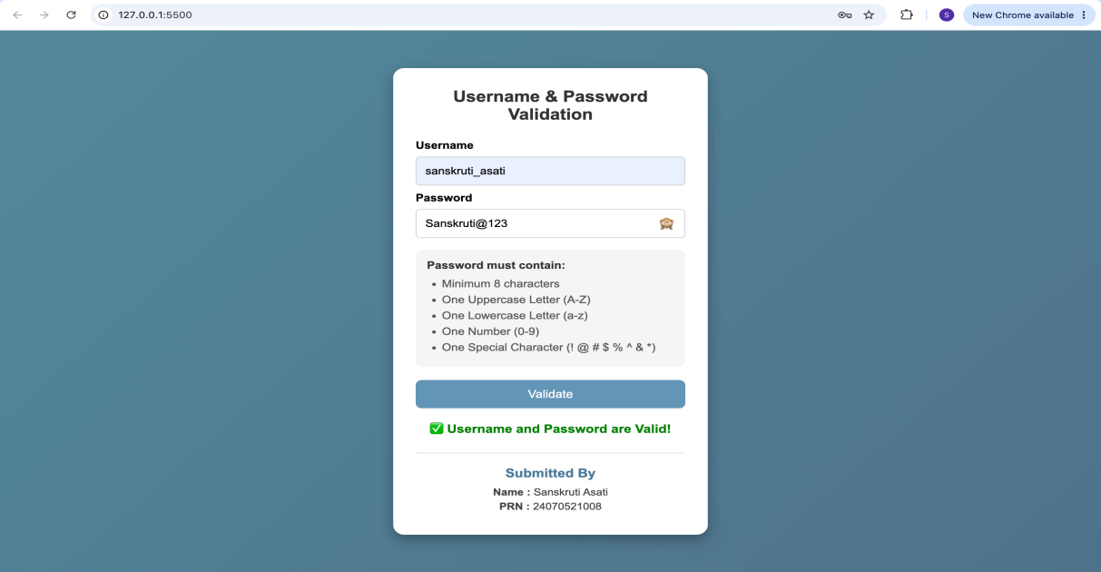

Conclusion –
The practical was completed successfully. Control structures (if-else, if-else-if, for loops, ternary operator) and form validation were implemented using JavaScript. A password validation system and a grading system were developed to validate user input and display the appropriate grade based on entered marks.

